BEACONHOUSE NATIONAL UNIVERSITY
School of Computing & Information Technology

LAB ASSIGNMENT

VLAN Configuration & Inter-VLAN Routing
Using Cisco Packet Tracer

Course | Computer Networks Lab (Lab-209)
Semester | Spring 2026
Institution | Beaconhouse National University
Instructor | Shazia Rizwan
Lab Instructor | Taqdees Gull
Total Marks | 20 Marks
CLOs Covered | CLO 4 (Apply — C3)
Submission | Submit .pkt file + screenshots via LMS

Student Name: Saad Mughal Roll No: F2023-009 Section: C

1. Learning Objectives

By the end of this lab, you will be able to:

- Explain what a VLAN is and why it is used in a switched network
- Create and name VLANs on a Cisco Catalyst switch
- Assign switch access ports to specific VLANs
- Configure trunk links between switches using 802.1Q encapsulation
- Implement Router-on-a-Stick (ROAS) for inter-VLAN routing on a Cisco router
- Configure Layer-3 Switch SVIs as an alternative to ROAS
- Verify VLAN configuration using show commands
- Test connectivity between hosts in different VLANs

Mapped CLO: CLO 4 — Configure network services in Cisco Packet Tracer [Apply — Bloom's C3]

2. Background Theory — VLANs

2.1 What is a VLAN?
A Virtual Local Area Network (VLAN) is a logical grouping of network devices that communicate as if they share the same physical LAN segment, regardless of their physical location.
Without VLANs, every device on a switch belongs to one large broadcast domain. As the network grows, this creates excessive broadcast traffic and security risks. VLANs solve this by dividing a single physical switch into multiple smaller, isolated broadcast domains.

2.2 Benefits of VLANs
Benefit | Explanation
Broadcast Containment | Broadcast frames stay within a VLAN — they do not cross to other VLANs.
Security | Devices in different VLANs are isolated. A router or Layer-3 switch is required for them to communicate, making it easy to apply access policies.
Flexibility | Devices can be logically grouped by function (e.g. Sales, HR, IT) regardless of where they are physically connected.
Performance | Smaller broadcast domains mean less unnecessary traffic and more available bandwidth.

2.3 Access Ports vs. Trunk Ports
Feature | Access Port | Trunk Port
Belongs to | One VLAN only | Multiple VLANs
Frame tagging | Untagged | 802.1Q tagged (except native VLAN)
Connected to | End devices (PCs) | Other switches or routers
IOS command | switchport mode access | switchport mode trunk

2.4 Inter-VLAN Routing
Hosts in different VLANs cannot reach each other without a Layer-3 device. Two methods are used in this lab:

- Router-on-a-Stick (ROAS) — One physical router interface is sub-divided into logical sub-interfaces. Each sub-interface is tagged for a VLAN and carries traffic for that VLAN between the router and the switch.
- Layer-3 Switch SVIs — A multilayer switch runs IP routing internally. Each VLAN is assigned a Switched Virtual Interface (SVI) with an IP address that acts as the default gateway for hosts in that VLAN.

2.5 Key IOS Commands Quick Reference
Command | Purpose
vlan <id> | Create a VLAN / enter VLAN config mode
name <name> | Name the VLAN
switchport mode access | Set port as access port
switchport access vlan <id> | Assign port to a VLAN
switchport mode trunk | Set port as trunk port
switchport trunk native vlan <id> | Set the native (untagged) VLAN on trunk
switchport trunk allowed vlan <list> | Restrict VLANs permitted on trunk
interface g0/0.<id> | Create a router sub-interface
encapsulation dot1Q <vlan-id> | Bind sub-interface to a VLAN (ROAS)
ip routing | Enable Layer-3 routing on a switch
interface vlan <id> | Create an SVI on a Layer-3 switch
show vlan brief | Show all VLANs and port assignments
show interfaces trunk | Show trunk ports and allowed VLANs
show ip route | Show routing table

3. Lab Topology

3.1 Overview
The topology models a small company with three departments — Sales, HR, and IT — spread across two access switches. A Layer-3 distribution switch (DS1) handles inter-VLAN routing. A router (R1) connects the network to the internet. A dedicated Management VLAN (VLAN 40) is used for remote switch administration.
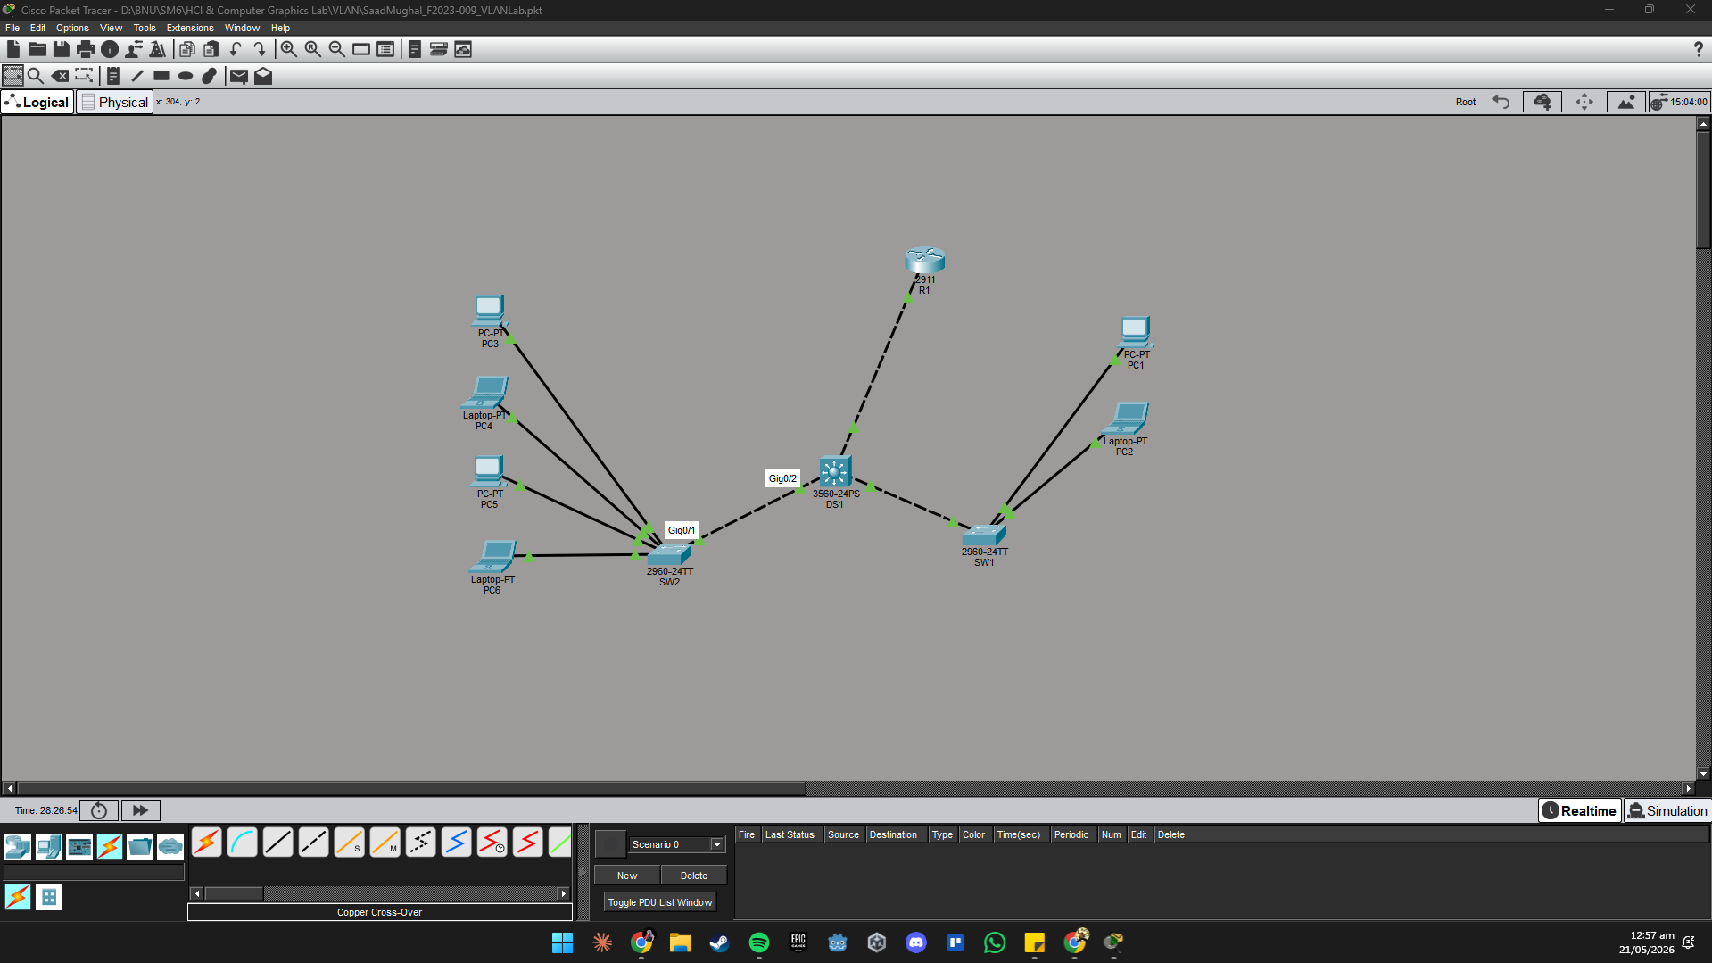

3.2 VLAN Plan
VLAN ID | Name | Subnet | Department
10 | SALES | 192.168.10.0 /24 | Sales Department
20 | HR | 192.168.20.0 /24 | Human Resources
30 | IT | 192.168.30.0 /24 | IT Department
40 | MGMT | 192.168.40.0 /24 | Switch Management
99 | NATIVE | N/A | Native VLAN for trunks

3.3 IP Address Plan
Device | Interface | IP Address | Notes
R1 | G0/1.10 | 192.168.10.1 /24 | ROAS — VLAN 10 gateway
R1 | G0/1.20 | 192.168.20.1 /24 | ROAS — VLAN 20 gateway
R1 | G0/1.30 | 192.168.30.1 /24 | ROAS — VLAN 30 gateway
R1 | G0/1.40 | 192.168.40.1 /24 | ROAS — VLAN 40 gateway
DS1 | SVI VLAN 10 | 192.168.10.2 /24 | L3 SVI (Task 4)
DS1 | SVI VLAN 20 | 192.168.20.2 /24 | L3 SVI (Task 4)
DS1 | SVI VLAN 30 | 192.168.30.2 /24 | L3 SVI (Task 4)
SW1 | SVI VLAN 40 | 192.168.40.11 /24 | Management IP
SW2 | SVI VLAN 40 | 192.168.40.12 /24 | Management IP
PC1 | NIC | 192.168.10.10 /24 | GW: 192.168.10.1
PC2 | NIC | 192.168.10.11 /24 | GW: 192.168.10.1
PC3 | NIC | 192.168.20.10 /24 | GW: 192.168.20.1
PC4 | NIC | 192.168.20.11 /24 | GW: 192.168.20.1
PC5 | NIC | 192.168.30.10 /24 | GW: 192.168.30.1
PC6 | NIC | 192.168.30.11 /24 | GW: 192.168.30.1

4. Lab Tasks

Note: Complete Tasks 1–4 in order. Task 5 is a Challenge Task — no step-by-step commands are given. Apply everything you have learned.

Task 1 — Build Topology & Create VLANs [4 Marks]
In this task you will place devices in Packet Tracer, cable them together, and create the VLAN database on every switch.

Step 1.1 — Add and Label Devices
- Open Cisco Packet Tracer and create a new blank project.
- Add devices: 1× Cisco 2911 Router (R1), 1× Cisco 3560 L3 Switch (DS1), 2× Cisco 2960 Switch (SW1, SW2), and 6× Generic PCs.
- Double-click each device name and label them: R1, DS1, SW1, SW2, PC1–PC6.

Step 1.2 — Connect Devices
- Connect PC1 and PC2 to SW1 Fa0/1 and Fa0/2 using straight-through copper cables.
- Connect PC3 and PC4 to SW2 Fa0/1 and Fa0/2.
- Connect PC5 and PC6 to SW2 Fa0/3 and Fa0/4.
- Connect SW1 G0/1 → DS1 G0/1 (cross-over or auto-MDI).
- Connect SW2 G0/1 → DS1 G0/2.
- Connect DS1 G0/3 → R1 G0/1.

Step 1.3 — Create VLANs on SW1
SW1> enable
SW1# configure terminal
!
SW1(config)# vlan 10
SW1(config-vlan)# name SALES
SW1(config-vlan)# exit
!
SW1(config)# vlan 20
SW1(config-vlan)# name HR
SW1(config-vlan)# exit
!
SW1(config)# vlan 40
SW1(config-vlan)# name MGMT
SW1(config-vlan)# exit
!
SW1(config)# vlan 99
SW1(config-vlan)# name NATIVE
SW1(config-vlan)# exit

Step 1.4 — Create VLANs on SW2
Repeat the same procedure on SW2. Also add VLAN 30 (IT) since SW2 connects the IT department:
SW2(config)# vlan 20
SW2(config-vlan)# name HR
SW2(config-vlan)# exit
!
SW2(config)# vlan 30
SW2(config-vlan)# name IT
SW2(config-vlan)# exit
!
SW2(config)# vlan 40
SW2(config-vlan)# name MGMT
SW2(config-vlan)# exit
!
SW2(config)# vlan 99
SW2(config-vlan)# name NATIVE
SW2(config-vlan)# exit

Step 1.5 — Create VLANs on DS1
DS1 must know all VLANs because it is the distribution switch connecting both access switches:
DS1(config)# vlan 10
DS1(config-vlan)# name SALES
DS1(config-vlan)# exit
!
DS1(config)# vlan 20
DS1(config-vlan)# name HR
DS1(config-vlan)# exit
!
DS1(config)# vlan 30
DS1(config-vlan)# name IT
DS1(config-vlan)# exit
!
DS1(config)# vlan 40
DS1(config-vlan)# name MGMT
DS1(config-vlan)# exit
!
DS1(config)# vlan 99
DS1(config-vlan)# name NATIVE
DS1(config-vlan)# exit

Step 1.6 — Verify
On each switch, run the following command and take a screenshot:
SW1# show vlan brief

Expected: All VLANs should appear as Active. The Ports column will be empty for now — ports are assigned in Task 2.
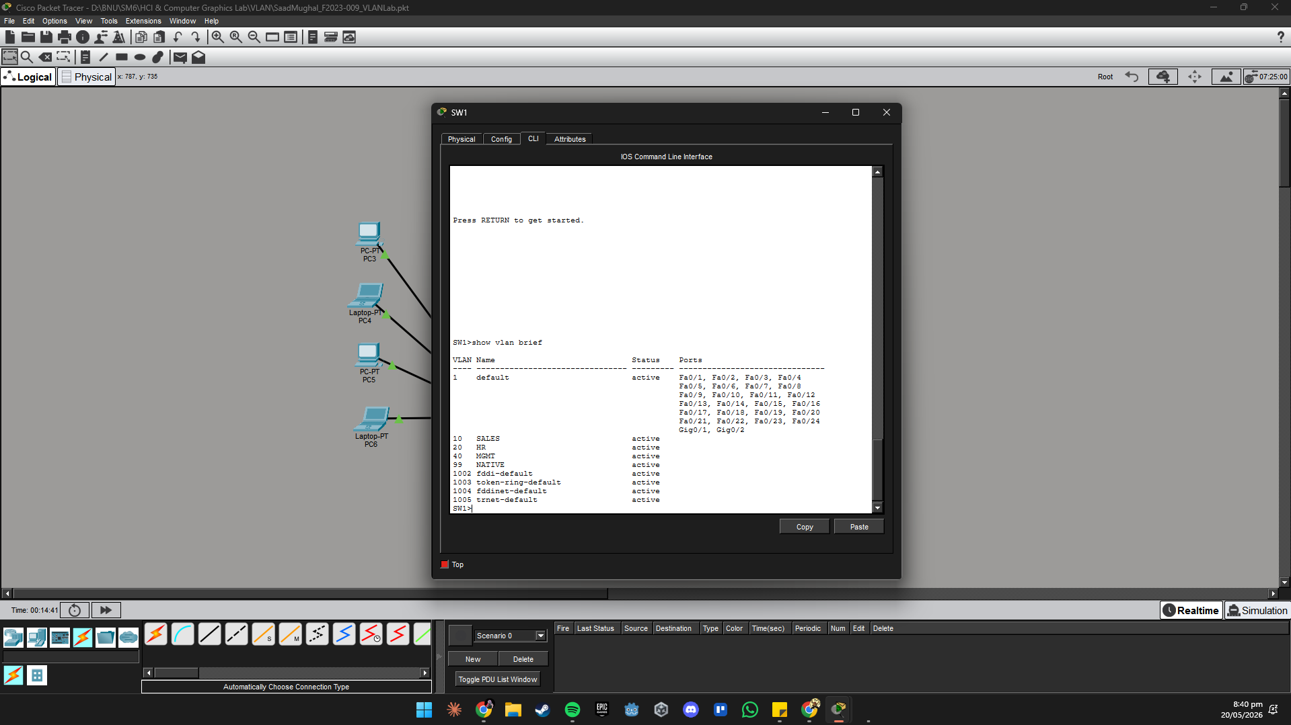
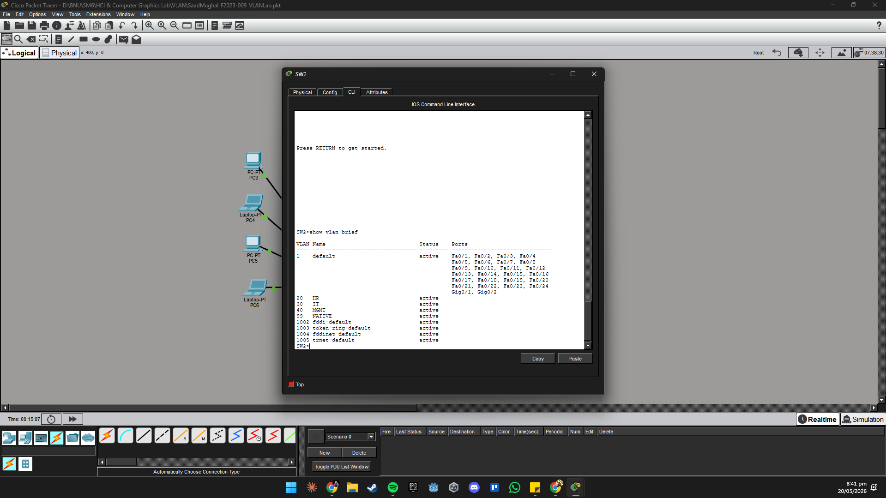
Questions
Q1: What is the difference between VLAN 1 and the VLANs you created? Why is it not recommended to use VLAN 1 for user traffic?
VLAN 1 is the default VLAN. All ports are assigned to it automatically, and it carries management traffic by default. It's not recommended for user traffic because it's a known default that attackers can exploit, and you can't delete or rename it, making it harder to secure.
Q2: Why must the same VLANs be created on DS1 even though end devices are not directly connected to it?
DS1 must know all VLANs because it's the distribution switch forwarding traffic between SW1 and SW2. If a VLAN isn't in DS1's database, it won't forward frames tagged with that VLAN ID even across trunk links.
Q3: After running 'show vlan brief', which VLANs showed no ports in the Ports column? Why?
All the VLANs you just created (10, 20, 30, 40, 99) show no ports, because no access ports have been assigned to them yet (that's done in Task 2). VLAN 1 may show some default ports.
Q4: What is the maximum number of VLANs supported by the 802.1Q standard? How many are usable?
802.1Q supports 4096 VLANs (IDs 0–4095). Usable range is 1–4094, VLAN 0 and 4095 are reserved.

Task 2 — Assign Access Ports & Configure Trunks [4 Marks]
In this task you will assign ports to VLANs and configure trunk links so tagged frames can travel between switches.

Step 2.1 — Assign Access Ports on SW1
SW1(config)# interface fa0/1
SW1(config-if)# switchport mode access
SW1(config-if)# switchport access vlan 10
SW1(config-if)# exit
!
SW1(config)# interface fa0/2
SW1(config-if)# switchport mode access
SW1(config-if)# switchport access vlan 10
SW1(config-if)# exit
!
SW1(config)# interface fa0/3
SW1(config-if)# switchport mode access
SW1(config-if)# switchport access vlan 20
SW1(config-if)# exit

Step 2.2 — Assign Access Ports on SW2
SW2(config)# interface fa0/1
SW2(config-if)# switchport mode access
SW2(config-if)# switchport access vlan 20
SW2(config-if)# exit
!
SW2(config)# interface fa0/2
SW2(config-if)# switchport mode access
SW2(config-if)# switchport access vlan 30
SW2(config-if)# exit
!
SW2(config)# interface fa0/3
SW2(config-if)# switchport mode access
SW2(config-if)# switchport access vlan 30
SW2(config-if)# exit

Step 2.3 — Configure Trunk on SW1 (uplink to DS1)
SW1(config)# interface g0/1
SW1(config-if)# switchport mode trunk
SW1(config-if)# switchport trunk native vlan 99
SW1(config-if)# switchport trunk allowed vlan 10,20,40,99
SW1(config-if)# no shutdown
SW1(config-if)# exit

Step 2.4 — Configure Trunk on SW2 (uplink to DS1)
SW2(config)# interface g0/1
SW2(config-if)# switchport mode trunk
SW2(config-if)# switchport trunk native vlan 99
SW2(config-if)# switchport trunk allowed vlan 20,30,40,99
SW2(config-if)# no shutdown
SW2(config-if)# exit

Step 2.5 — Configure Trunks on DS1 (towards SW1, SW2, and R1)
DS1(config)# interface g0/1
DS1(config-if)# switchport trunk encapsulation dot1q
DS1(config-if)# switchport mode trunk
DS1(config-if)# switchport trunk native vlan 99
DS1(config-if)# switchport trunk allowed vlan 10,20,40,99
DS1(config-if)# no shutdown
DS1(config-if)# exit
!
DS1(config)# interface g0/2
DS1(config-if)# switchport trunk encapsulation dot1q
DS1(config-if)# switchport mode trunk
DS1(config-if)# switchport trunk native vlan 99
DS1(config-if)# switchport trunk allowed vlan 20,30,40,99
DS1(config-if)# no shutdown
DS1(config-if)# exit
!
DS1(config)# interface g0/3
DS1(config-if)# switchport trunk encapsulation dot1q
DS1(config-if)# switchport mode trunk
DS1(config-if)# switchport trunk native vlan 99
DS1(config-if)# switchport trunk allowed vlan 10,20,30,40,99
DS1(config-if)# no shutdown
DS1(config-if)# exit

Step 2.6 — Verify Trunks
SW1# show interfaces trunk
DS1# show interfaces trunk

Expected: G0/1 should appear as trunking with native VLAN 99 and only the permitted VLANs listed under 'VLANs allowed and active'.

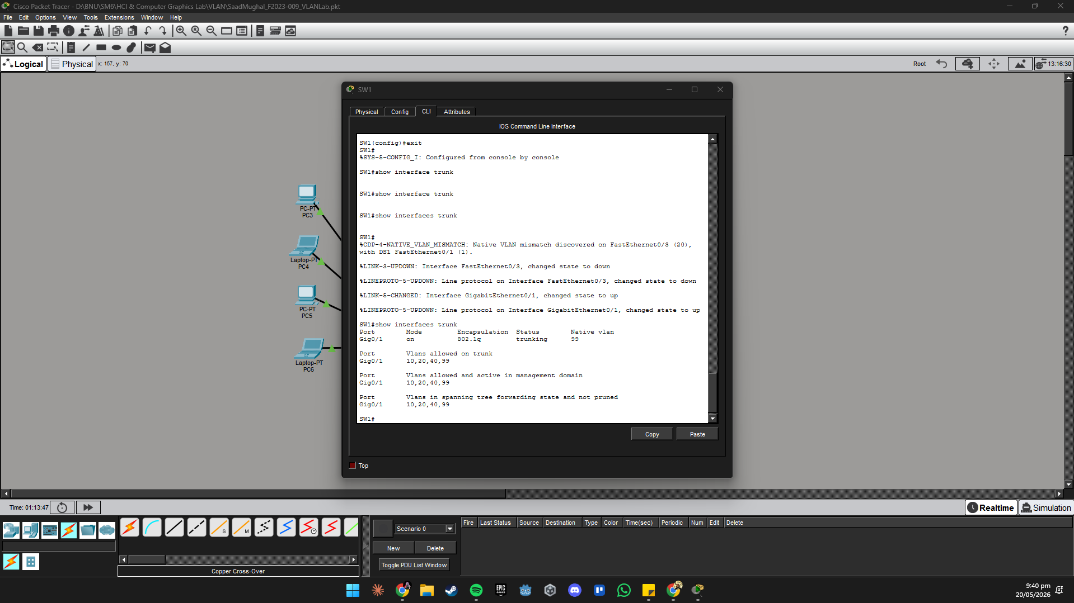
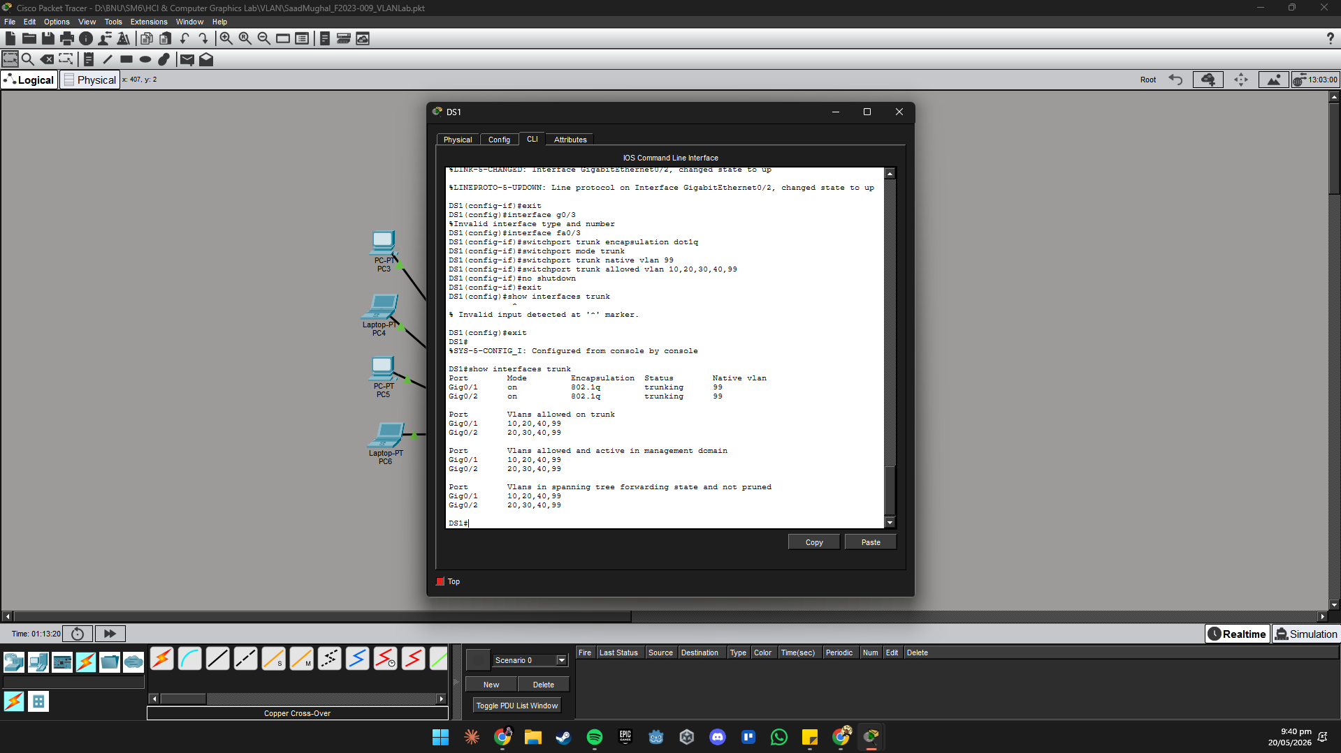

Questions
Q1: What does 'switchport trunk native vlan 99' do? What security risk does using the default native VLAN (VLAN 1) create?
It sets VLAN 99 as the untagged (native) VLAN on the trunk. Using the default VLAN 1 as native is a security risk because a VLAN hopping attack can inject untagged frames that get forwarded into VLAN 1, potentially reaching management interfaces.
Q2: Why was 'switchport trunk encapsulation dot1q' needed on DS1 but not on SW1 or SW2?
The 2960 (SW1, SW2) are Layer-2 only switches, they only support 802.1Q and default to it. The 3560 (DS1) is a Layer-3 switch that supports multiple encapsulation types, so you must explicitly specify dot1q before setting trunk mode.
Q3: In 'show interfaces trunk', what is the difference between 'VLANs allowed on trunk' and 'VLANs allowed and active in management domain'?
"VLANs allowed on trunk" = what you configured with switchport trunk allowed vlan. "VLANs allowed and active in management domain" = a subset of those, only VLANs that actually exist in the switch's VLAN database and are active.
Q4: What would happen if you forgot to add VLAN 30 to the allowed list on the DS1 G0/2 trunk port?
VLAN 30 traffic from SW2 would be blocked at DS1's G0/2 port. PC5 and PC6 (IT department) would be completely isolated, no inter-VLAN routing and no connectivity beyond SW2.

Task 3 — Router-on-a-Stick (Inter-VLAN Routing) [4 Marks]
In this task you will configure sub-interfaces on R1 to allow communication between hosts in different VLANs.

Step 3.1 — Enable the Physical Interface on R1
R1> enable
R1# configure terminal
!
R1(config)# interface g0/1
R1(config-if)# no ip address
R1(config-if)# no shutdown
R1(config-if)# exit

Step 3.2 — Create Sub-interfaces on R1
R1(config)# interface g0/1.10
R1(config-subif)# encapsulation dot1Q 10
R1(config-subif)# ip address 192.168.10.1 255.255.255.0
R1(config-subif)# exit
!
R1(config)# interface g0/1.20
R1(config-subif)# encapsulation dot1Q 20
R1(config-subif)# ip address 192.168.20.1 255.255.255.0
R1(config-subif)# exit
!
R1(config)# interface g0/1.30
R1(config-subif)# encapsulation dot1Q 30
R1(config-subif)# ip address 192.168.30.1 255.255.255.0
R1(config-subif)# exit
!
R1(config)# interface g0/1.40
R1(config-subif)# encapsulation dot1Q 40
R1(config-subif)# ip address 192.168.40.1 255.255.255.0
R1(config-subif)# exit
!
R1(config)# interface g0/1.99
R1(config-subif)# encapsulation dot1Q 99 native
R1(config-subif)# exit

Step 3.3 — Configure Static IPs on PCs
On each PC go to Desktop → IP Configuration and enter the values below:
PC | IP Address | Subnet Mask | Default Gateway
PC1 | 192.168.10.10 | 255.255.255.0 | 192.168.10.1
PC2 | 192.168.10.11 | 255.255.255.0 | 192.168.10.1
PC3 | 192.168.20.10 | 255.255.255.0 | 192.168.20.1
PC4 | 192.168.20.11 | 255.255.255.0 | 192.168.20.1
PC5 | 192.168.30.10 | 255.255.255.0 | 192.168.30.1
PC6 | 192.168.30.11 | 255.255.255.0 | 192.168.30.1

Step 3.4 — Verify and Test
R1# show ip interface brief
R1# show ip route

All sub-interfaces should be Up/Up. The routing table should show connected routes for all four subnets.
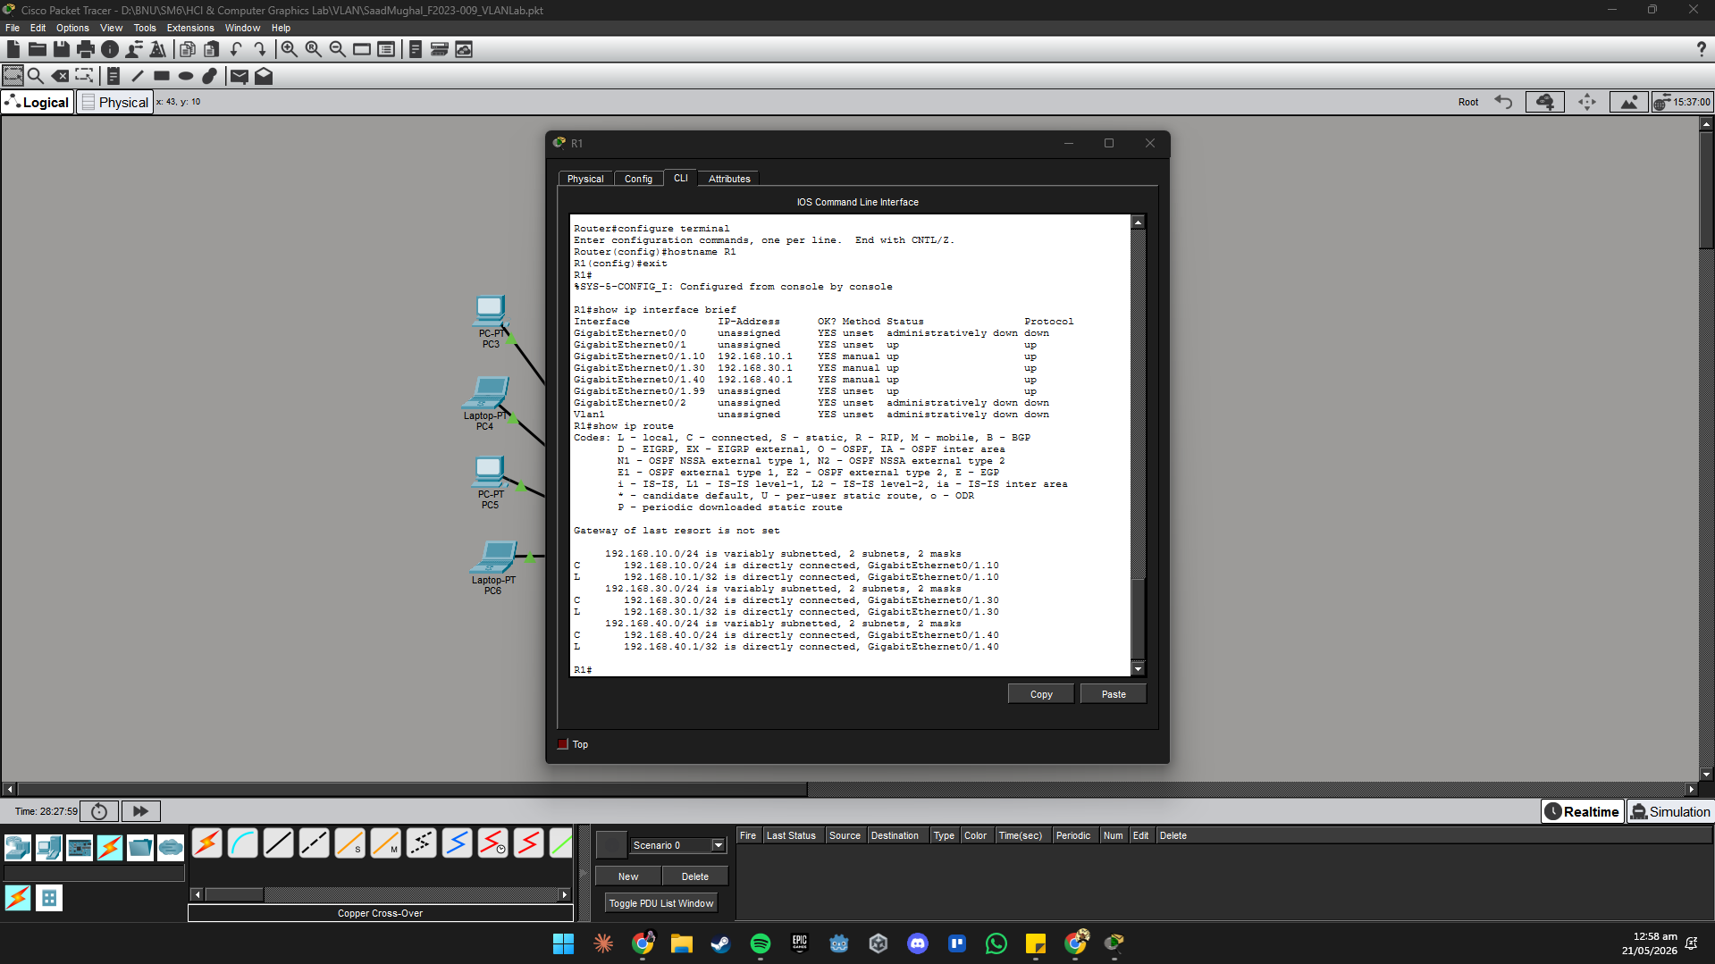
From PC1, open Desktop → Command Prompt and test connectivity:
! Intra-VLAN test (same VLAN — no router needed)
PC1> ping 192.168.10.11

! Inter-VLAN test (different VLAN — must go through R1)
PC1> ping 192.168.20.10

! Trace the path to see R1 as the first hop
PC1> tracert 192.168.20.10

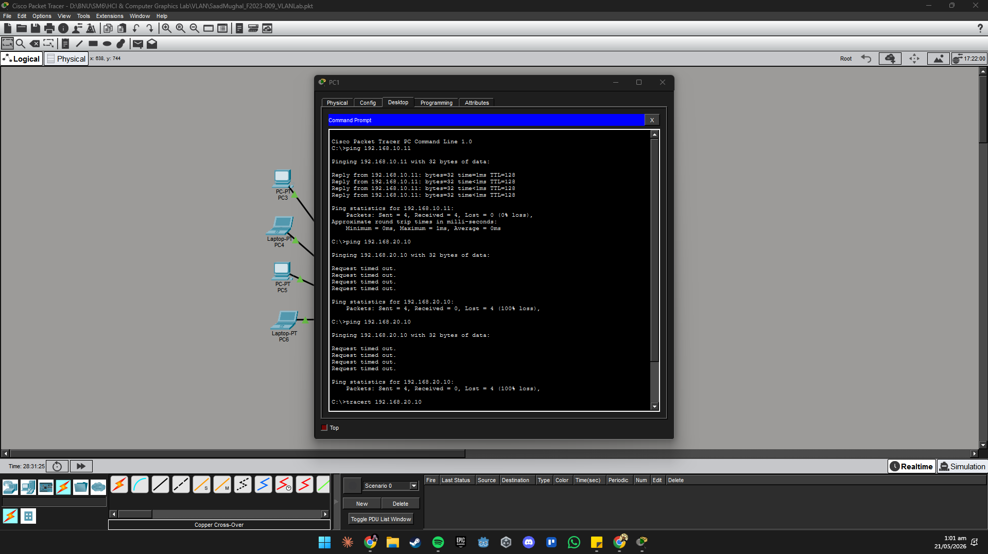

Expected: The ping to PC3 (VLAN 20) should succeed. The tracert should show 192.168.10.1 (R1 sub-interface G0/1.10) as the first hop, confirming inter-VLAN routing is working.

Questions
Q1: What does 'encapsulation dot1Q 10' do on a router sub-interface? What would happen if this command was missing?
encapsulation dot1Q 10 tells the sub-interface to tag/accept frames with VLAN 10 tag. Without it, the sub-interface won't know which VLAN it belongs to and R1 won't be able to route traffic for that VLAN.
Q2: In your tracert output from PC1 to PC3, how many hops were shown? Identify each hop and what device it corresponds to.
The tracert from PC1 to PC3 will show 2 hops: Hop 1 = 192.168.10.1 (R1 sub-interface G0/1.10), Hop 2 = 192.168.20.10 (PC3 - destination). The router routes between the two subnets.
Q3: Why does the intra-VLAN ping (PC1 to PC2) succeed even without configuring anything on R1?
PC1 and PC2 are in the same VLAN (10) and same subnet (192.168.10.0/24). Switches forward traffic within a VLAN using MAC addresses, no routing needed. The frame never needs to leave the switch.
Q4: What is the main disadvantage of Router-on-a-Stick compared to using a Layer-3 switch?
The main disadvantage is that all inter-VLAN traffic must physically travel up to R1 and back down through a single physical link, this becomes a bottleneck. A Layer-3 switch routes internally at wire speed without that single chokepoint.

Task 4 — Layer-3 Switch Inter-VLAN Routing with SVIs [4 Marks]
In this task you will configure DS1 as the routing device using Switched Virtual Interfaces (SVIs). This is a more efficient alternative to Router-on-a-Stick.

Step 4.1 — Enable IP Routing on DS1
DS1> enable
DS1# configure terminal
!
DS1(config)# ip routing

Step 4.2 — Create SVIs on DS1
DS1(config)# interface vlan 10
DS1(config-if)# ip address 192.168.10.2 255.255.255.0
DS1(config-if)# no shutdown
DS1(config-if)# exit
!
DS1(config)# interface vlan 20
DS1(config-if)# ip address 192.168.20.2 255.255.255.0
DS1(config-if)# no shutdown
DS1(config-if)# exit
!
DS1(config)# interface vlan 30
DS1(config-if)# ip address 192.168.30.2 255.255.255.0
DS1(config-if)# no shutdown
DS1(config-if)# exit
!
DS1(config)# interface vlan 40
DS1(config-if)# ip address 192.168.40.2 255.255.255.0
DS1(config-if)# no shutdown
DS1(config-if)# exit

Step 4.3 — Update PC Default Gateways
Change the default gateway on all PCs from R1 sub-interfaces to DS1 SVIs (192.168.x.2). DS1 will now handle all inter-VLAN routing locally.
PC | IP Address | New Default Gateway
PC1 | 192.168.10.10 | 192.168.10.2 (DS1 SVI VLAN 10)
PC2 | 192.168.10.11 | 192.168.10.2 (DS1 SVI VLAN 10)
PC3 | 192.168.20.10 | 192.168.20.2 (DS1 SVI VLAN 20)
PC4 | 192.168.20.11 | 192.168.20.2 (DS1 SVI VLAN 20)
PC5 | 192.168.30.10 | 192.168.30.2 (DS1 SVI VLAN 30)
PC6 | 192.168.30.11 | 192.168.30.2 (DS1 SVI VLAN 30)

Step 4.4 — Verify and Test
DS1# show ip route
DS1# show interfaces vlan 10

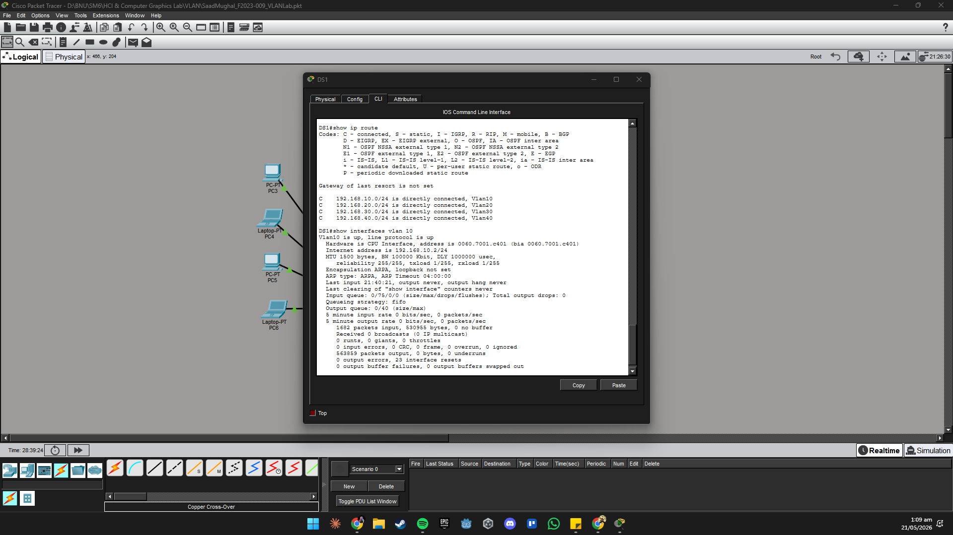

From PC1, test inter-VLAN routing through DS1:
PC1> ping 192.168.30.10

PC1> tracert 192.168.30.10

Expected: The tracert should now show 192.168.10.2 (DS1 SVI) as the first hop — not R1. Only traffic going to the internet will pass through R1.

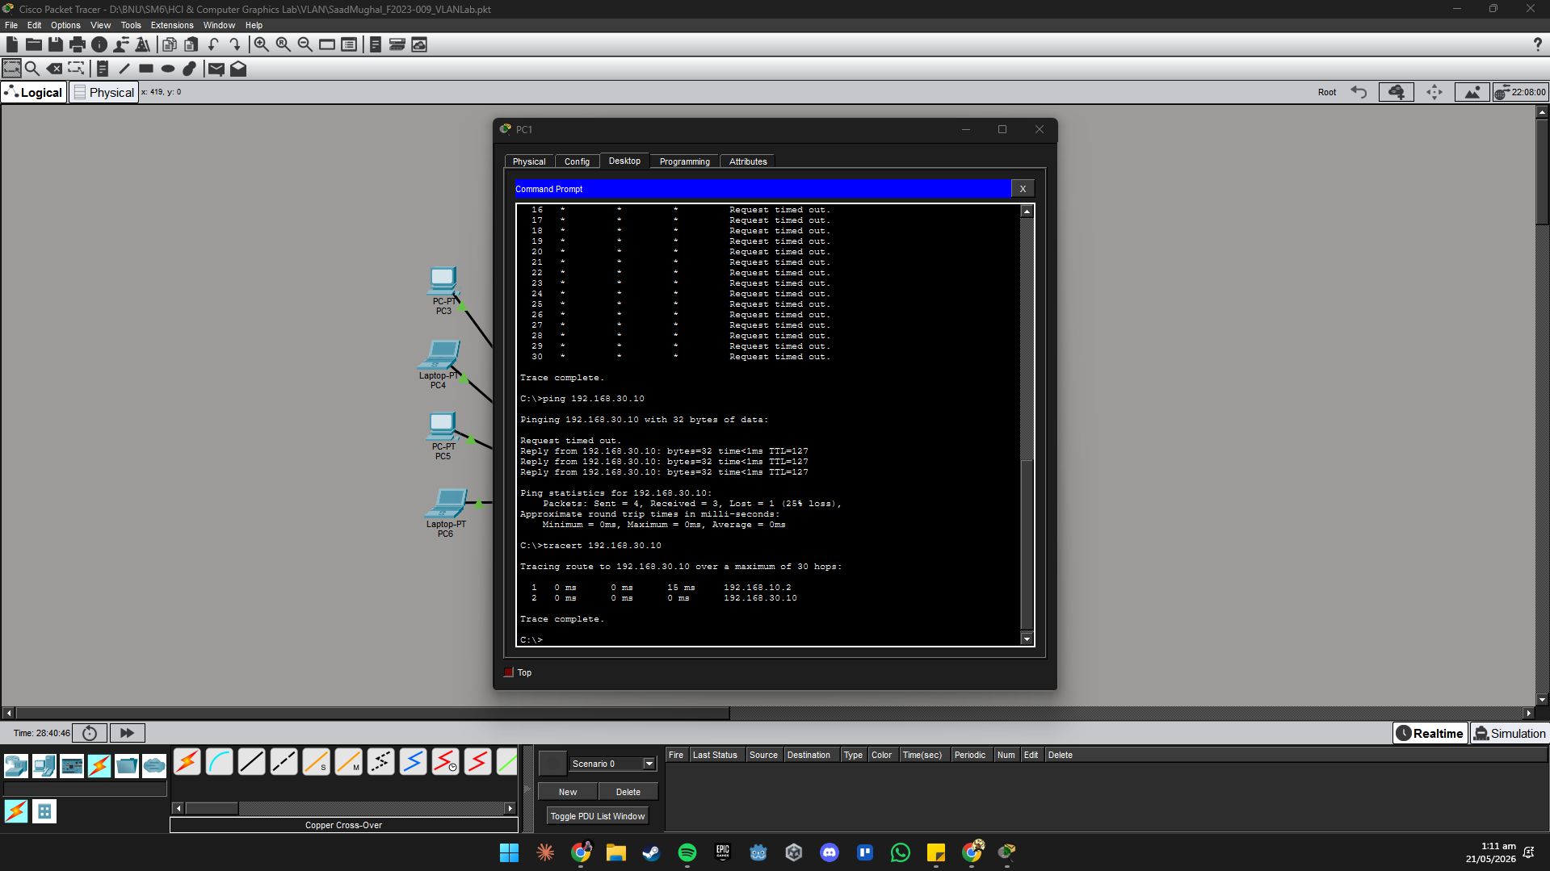

Questions
Q1: What is a Switched Virtual Interface (SVI)? How is it different from a physical routed port?
An SVI is a virtual Layer-3 interface associated with a VLAN on a multilayer switch, it has an IP address and acts as the default gateway for hosts in that VLAN. Unlike a physical routed port (which is dedicated to one link), an SVI represents an entire VLAN and can span multiple physical ports.
Q2: After enabling 'ip routing' on DS1, what new routes appeared in 'show ip route'? Label each one as C (connected) or S (static).
After ip routing, the routing table will show C (connected) routes for each SVI subnet: C 192.168.10.0/24, C 192.168.20.0/24, C 192.168.30.0/24, C 192.168.40.0/24. No static routes are needed because all subnets are directly connected via SVIs.
Q3: An SVI only comes Up if at least one physical port in that VLAN is active. Shut down all ports in VLAN 10 on SW1 — what happens to the VLAN 10 SVI on DS1?
The VLAN 10 SVI on DS1 will go down/down. An SVI requires at least one active port in that VLAN to stay up. Shutting all VLAN 10 ports on SW1 removes the active path, so the SVI goes down.
Q4: Compare Router-on-a-Stick (Task 3) and Layer-3 SVI routing (Task 4). In a real network with 50 VLANs, which would you choose and why?
With 50 VLANs, Layer-3 SVI routing is the clear choice. ROAS would require 50 sub-interfaces on one physical link, that single link becomes a massive bottleneck and a single point of failure. DS1 routes internally at hardware speed, scales easily to 50 VLANs, and doesn't bottleneck on a single uplink.

5. Deliverables & Submission

Submit all of the following via LMS before the deadline:

# | Deliverable | Details
1 | Packet Tracer File (.pkt) | YourName_RollNo_VLANLab.pkt — fully configured topology.
2 | Topology Screenshot | Full workspace with all devices, cables, labels, and green link lights.
3 | 'show vlan brief' from SW1 & SW2 | Screenshot showing all VLANs and correct port assignments.
4 | 'show interfaces trunk' from DS1 | Screenshot showing trunk ports, native VLAN, and active VLANs.
5 | 'show ip route' from DS1 | Screenshot of routing table after enabling ip routing and SVIs.
6 | Inter-VLAN ping output | Successful ping from PC1 (VLAN 10) to PC5 (VLAN 30).
7 | tracert output | tracert from PC1 to PC5 showing the routing path through DS1.
8 | Completed Answer Questions | All questions answered on this document.

Marking Rubric
Task | Marks | Key Criteria
Task 1 — Topology & VLAN Creation | 5 | All VLANs created, named, and verified with screenshot
Task 2 — Access Ports & Trunks | 5 | Correct port assignments, trunk config verified
Task 3 — Router-on-a-Stick | 5 | Sub-interfaces correct, inter-VLAN ping successful
Task 4 — Layer-3 Switch SVIs | 5 | ip routing enabled, SVIs Up, routing table correct
TOTAL | 20

